QA Engineer

Skill Assessment

# Assessment overview

One of the main purposes of a QA Engineer is to analyse and review requirements to generate a list of test items. This way, the QA Engineer will be creating a baseline to ensure that the identified items can be verified by testing.

The objective of this assessment is to allow a prospective candidate to demonstrate organisational skills, attention to detail as well as communication skills.

# Assessment delivery

Once you conclude all the tasks, please send us your activity products (Test Plans, Bug reports, summary reports and Collections) so that each can reviewed and evaluated. You are also encouraged to use online repos such as GiHub for your deliverables.

# Exploring an Ecommerce page

The first part of the assessment will focus on developing manual tests for an existing website.

## Website under test

The website that you will need to test is saucedemo.com. It is an e-commerce mock website where one can purchase items. It has a shopping cart that keeps track of the items that the user would like to purchase.

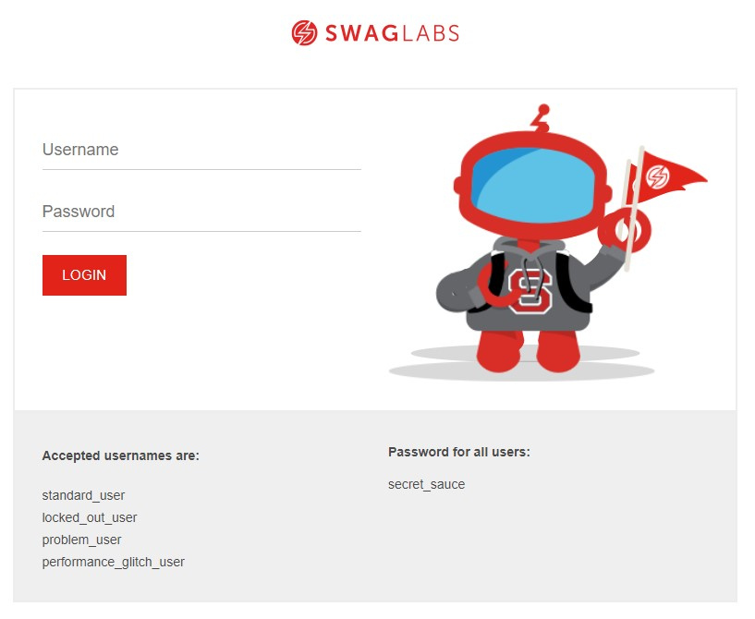

## Objectives

Identify core test cases that will need to be part of the Regression test suite so that they can be executed when a regression run is triggered by a change in the product, or when core updates are applied.

Deliverables:

1. A brief test plan, including the testing strategy highlighting your approach. The strategy should identify what needs to be checked depending on the nature of the changes. For example, changes on the UI should include cross browser checks, while backend changes may require focus on specific areas. This document should ideally not exceed 3 pages.
2. A spreadsheet containing the tests. The template, structure, and fields of the test cases are up to you to define. Giving importance to the execution order, the priority, and which tests are ideal candidates for automation is encouraged.
3. Establish a template to report any issues or queries found (if any), use the template so that any issues are reported in a separate document using this template.

# Exploring a RESTful API Service

APIs form a big chunk of how modern systems communicate with one another. It is not uncommon that changes or features requested are implemented solely at an API level; hence the QA team must have a posture to cater for such initiatives, especially when no UI changes are involved, or are coming later in the cycle. The first part of the task focuses on identifying a viable strategy to test APIs, while the final part of the assessment focuses on consuming and testing out a RESTful API. You can find the mock API documented in a swagger file via the following link.

|  |
| --- |
| <https://fakerestapi.azurewebsites.net/index.html> |

## Objectives

Define a good overall testing strategy document on how you would verify the above API. The strategy should provide testing at various levels, including performance. Additionally, execute some of the tests and provide testing evidence.

## Deliverables

1. A Test Plan document with positive and negative test cases at various levels (system, integration, end to end, performance, etc) to test the API. The test cases must be prioritised accordingly so that the most critical tests are executed before those which are of lower priority.
2. A test execution run highlighting which tests were executed as well as their respective results.
3. Optionally, a simple postman collection which aims to facilitate QA effort to repeat the tests. While this is not mandatory, knowing how to invoke the API will provide the automation testers with a head start.
4. Propose improvements where your tests might help the company adopt a shift left policy.

TIP: While it is not mandatory to create an entire collection which can be run with a single action, it would be advantageous to attempt to use techniques which facilitate this, such as CRUD, parametrisation, and test assertions.